**ENSF 480: Project 1, Part 2**

**Huzaifa Amar (30020872)**

**Daniel Guieb (30024834)**

**November 14, 2018**

**Sequence Diagrams**

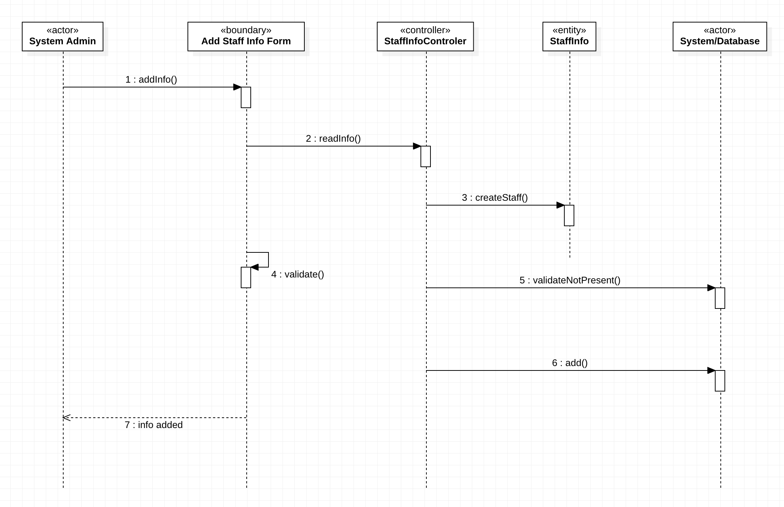Add Staff Info:

Search Documents:

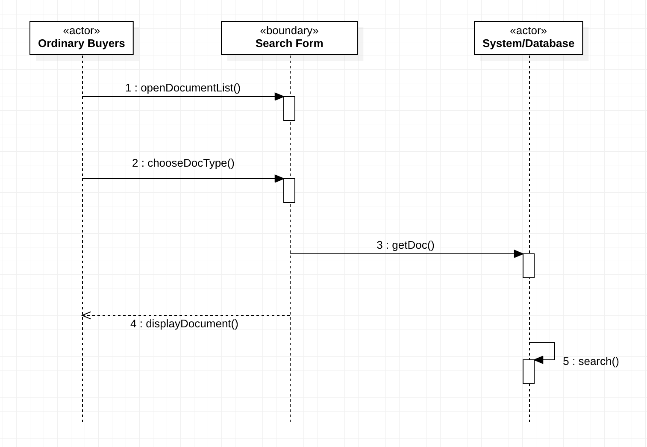

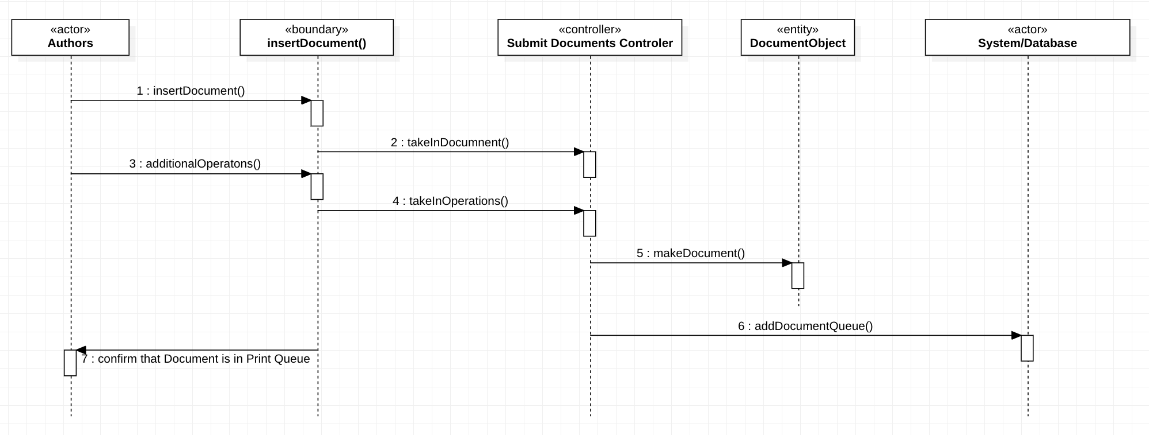Submit Documents:

**State Transition Diagrams**

Add Staff Info:

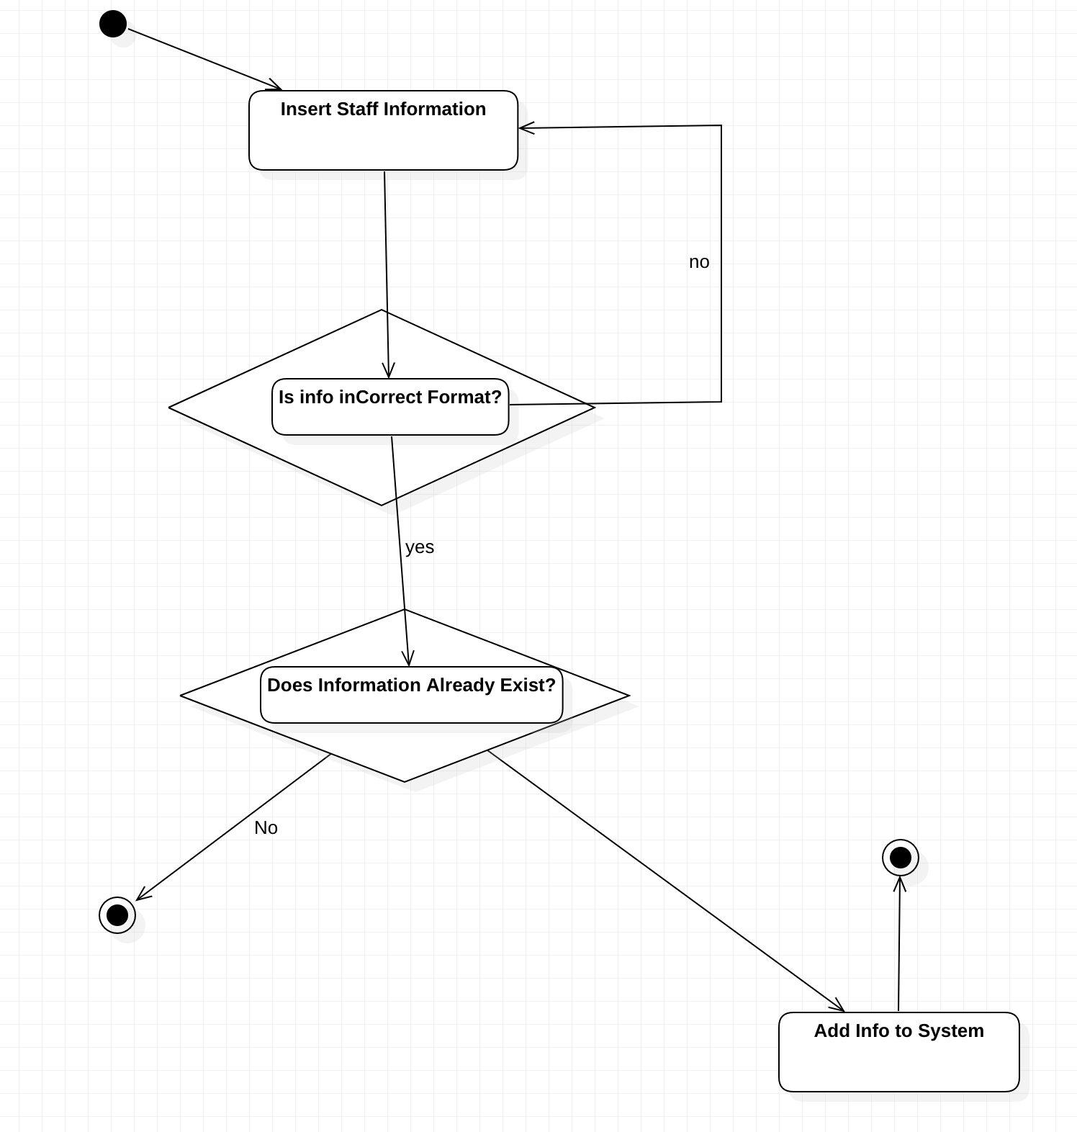

Search Documents:

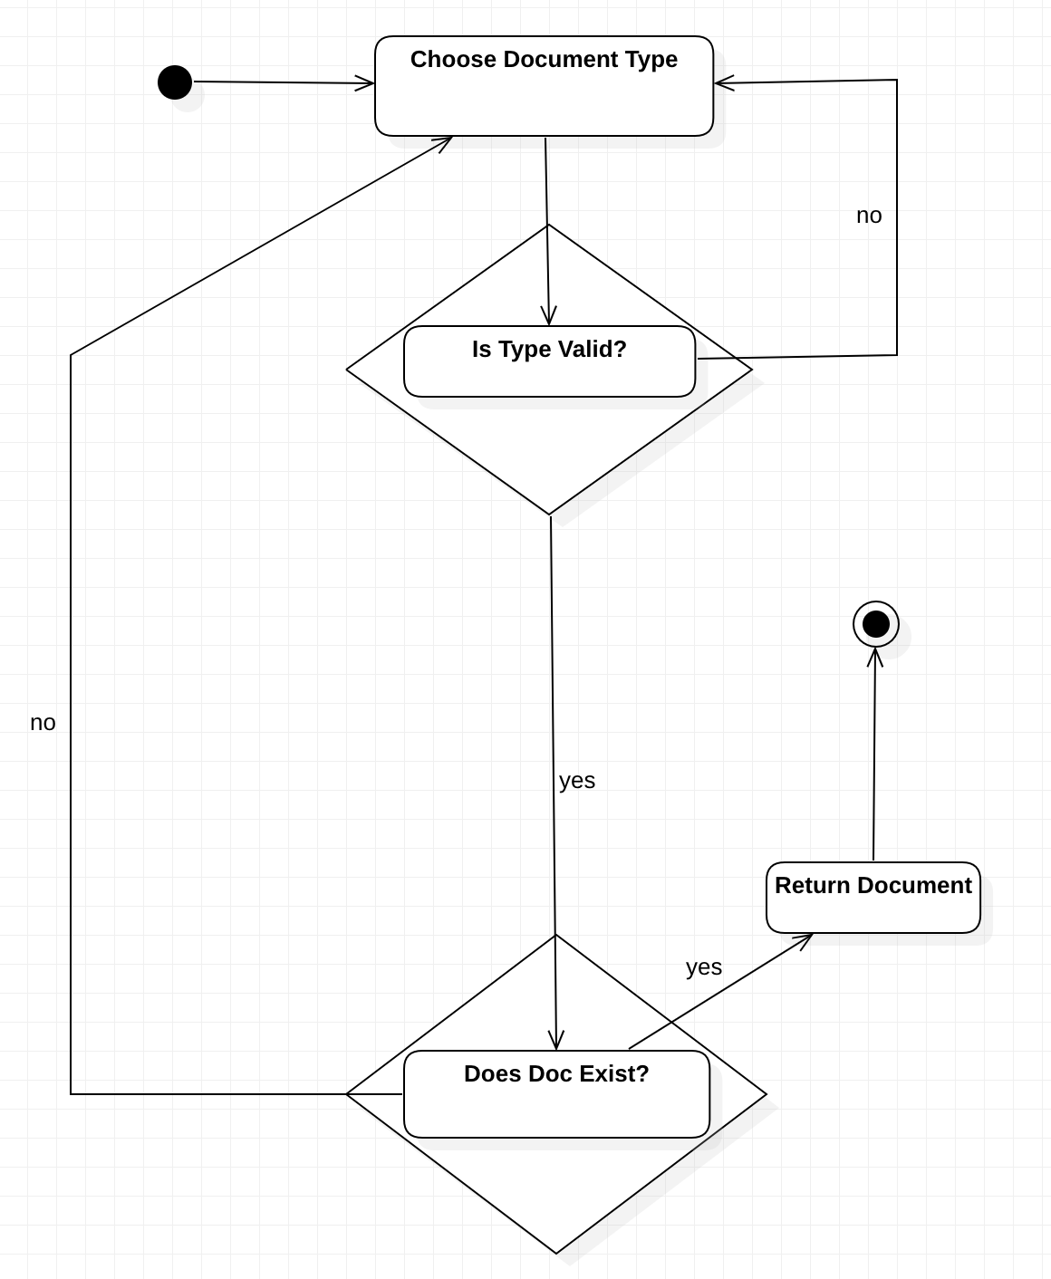

Submit Documents:

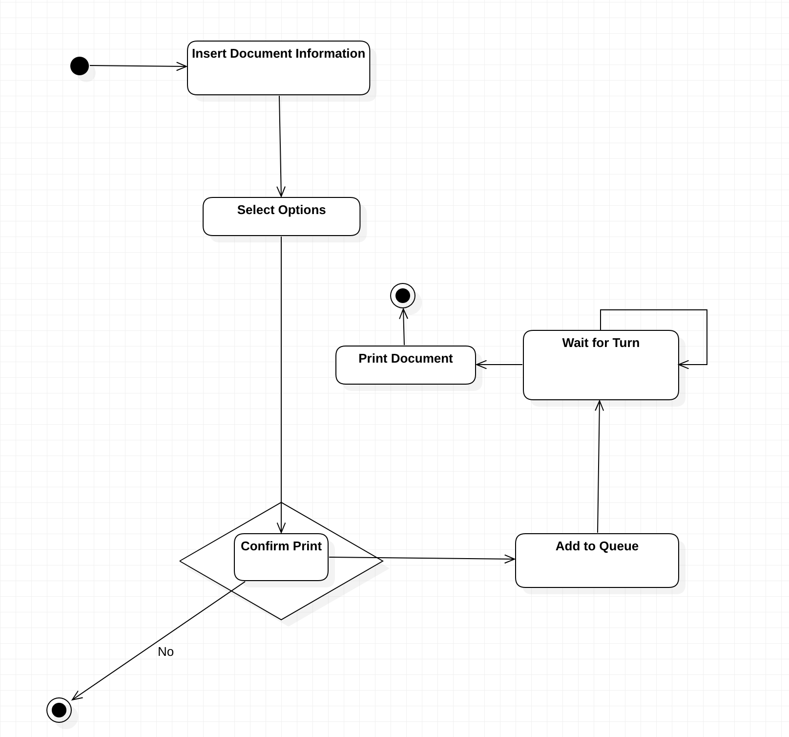

**Class Diagrams**

Notes before we start

* Documents inventory entity will be a database
* The print class will be implemented as a singleton pattern
* Staff list is also a database
* Book’s cover types will be decided by the decorator pattern

*Brief class descriptions:*

User

The abstract super class of which the other users extend from

Holds: user ID, user password, user name, login object

Functions: login, logout, make user

Login

A class User uses for logging in

Holds: a variable that connects it to the user database controller

Functions: validate

Manager

A subclass of User for managers

Holds: mangerForm which connects it to the ManagerForm class

Functions: browse documents

SystemAdmin

A subclass of User for the system admin

Holds: sysForm which connects it to the SystemAdminForm class

Functions: add staff info, remove staff info, update staff info

Author

A subclass of User for authors

Holds: list of contributed documents, authorForm which connects it to the AuthorForm

Functions: submit documents to be published

Operator

A subclass of User for operators

Holds: operatorForm which connects it to the OperatorForm

Functions: add document, remove document, update document

OrdinaryBuyer

A subclass of User for non-registered buyers

Holds: a list of transactions, buyerForm which connects it to the BuyerForm

Functions: search documents, order documents, pay documents, register

RegisteredBuyer

A subclass of OrdinaryBuyer for registered buyers

Holds: promotion list to read from

Functions: access promotion list, unsubscribe

TransactionHistory

A class which holds information on a buyer’s past transactions

Holds: list of receipts

Functions: calculate total sum of payments

Receipt

A class which records a purchase details

Holds: price, date, list of items

Functions: none

Staff

A class which represents a staff member’s info

Holds info: first name, last name, position

Functions: none

Document

An abstract class which represents a document’s info

Holds: name, author, document ID, publication date, publisher

Functions: none

Book

A class which holds information of a book object; subclass of document

Holds: genre, a Boolean to determine if it’s fiction or not, and a component variable linking it to the decorator pattern

Functions: none

Journal

A class which holds information of a journal object; subclass of document

Holds: an array list of the co-contributors to the journal

Functions: none

Magazine

A class which holds information of a magazine object; subclass of document

Holds: a Boolean variable called isOngoing to see if the magazine is still being published

Functions: none

PromotionList

A class which represents the documents that are tagged as promoted in the database

Holds: list of documents, list of observers

Functions: none

Publish

A class which holds the queue of documents to publish, implements singleton design pattern

Holds: documents queue, a publish object

Functions: publish next, add document, get instance of publish

SystemAdminForm

A class which is the interface between the SystemAdmin and the StaffInfoDatabaseController

Holds: system admin name, system admin ID, StaffInfoDataBaseController object

Functions: add, remove, update

ManagerForm

A class which is the interface between the Manager and the DocumentDatabaseController

Holds: manager name, manager ID, DocumentDatabaseController object

AuthorForm

A class which is the interface between the Author and the Publish class

Holds: author name, author ID, publish object

Functions: publish

BuyerForm

A class which is the interface between the Buyer and the DocumentDatabaseController

Holds: buyer name, buyer ID, DocumentDatabaseController object

Functions: search, order, pay, register, unregister, access promotion list

OperatorForm

A class which is the interface between the Operator and the DocumentDatabaseController

Holds: operator name, operator ID, DocumentDatabaseControllerobject

Functions: add, remove, update

UserDatabaseController

A class which controls the reads from a user database

Holds: database name, database connection

Functions: read from database

StaffInfoDatabaseController

A class which controls the reads and writes to a staff info database

Holds: database name, database connection

Functions: add to database, remove from database, update database

DocumentDatabaseController

A class which controls the reads and writes to a document database

Holds: database name, database connection

Functions: add to database, remove from database, update database, get list of documents

GeneralBookFormat, GenericJournalFormat, and GenericMagazineFormat are strategies to set at runtime which will have algorithms to publish different types of documents.

DocumentDecorator is an abstract superclass which implements and owns a component used to decorate. CoverLayerOpaquity and BackgroundImage are subclasses of DocumentDecorator that own a component themselves which allows for them to decorate. CoverBoarder implements Component but does not own a component itself so it is the last Component to add.

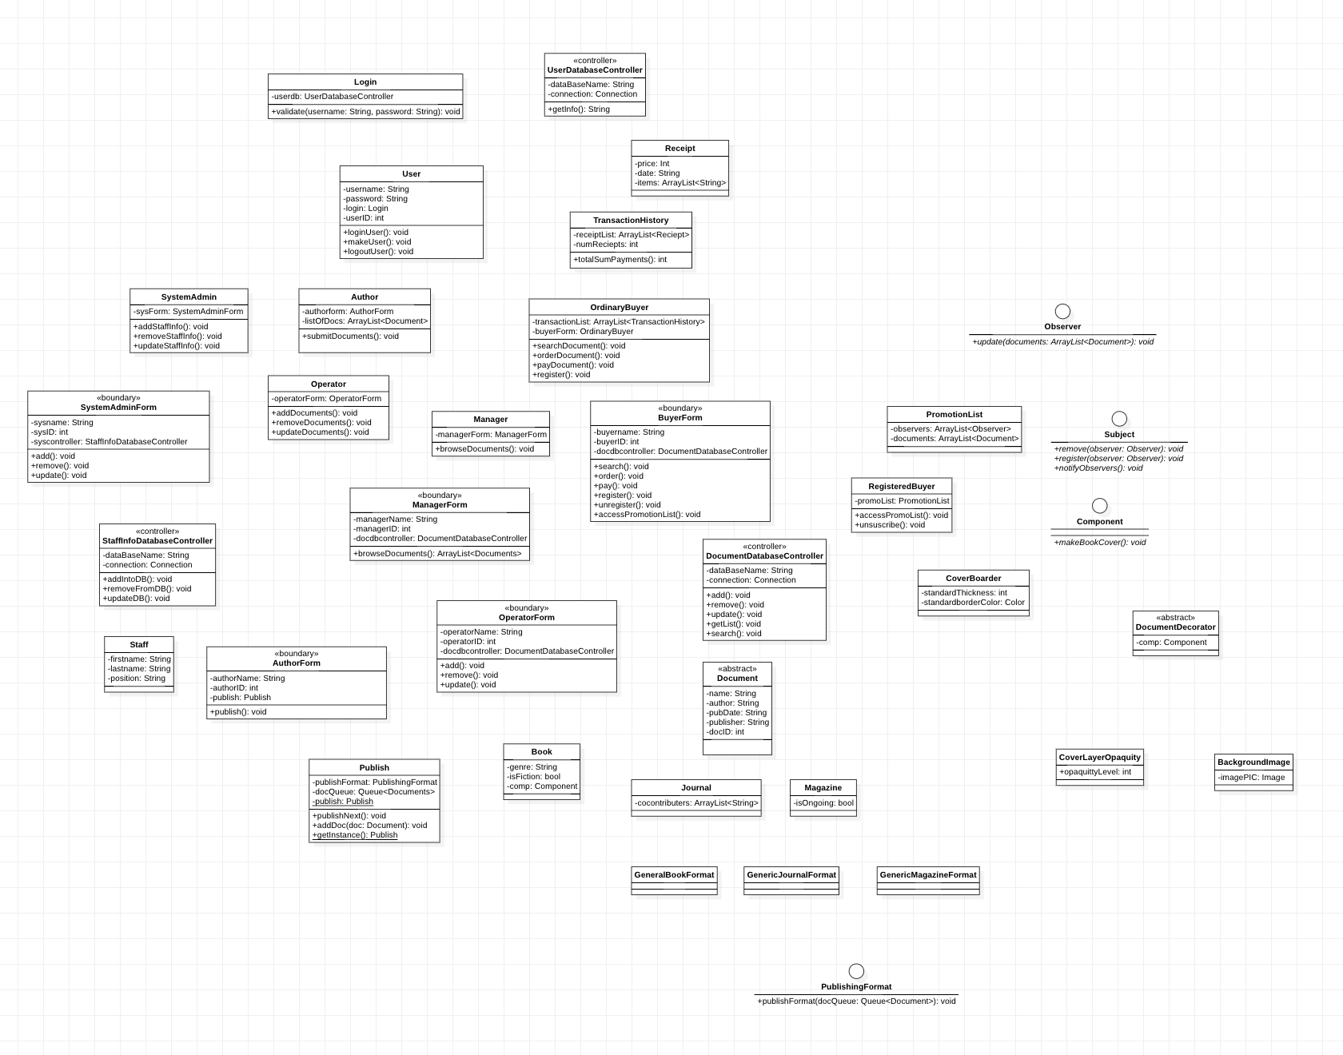With Details:

Without Details:

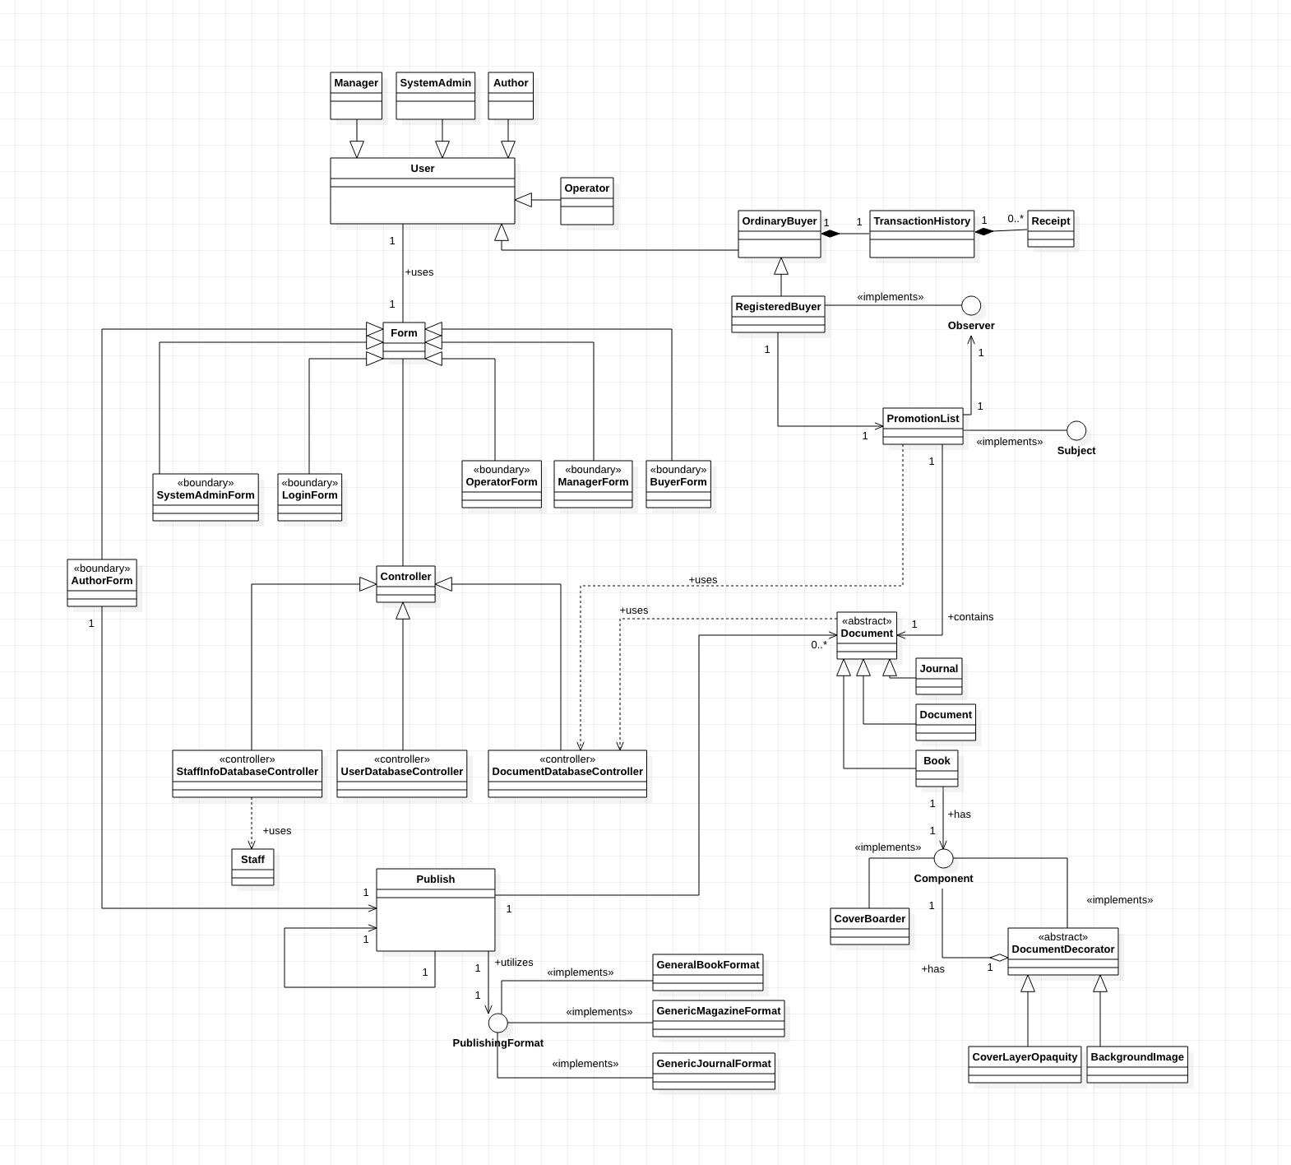

**Package Diagram**

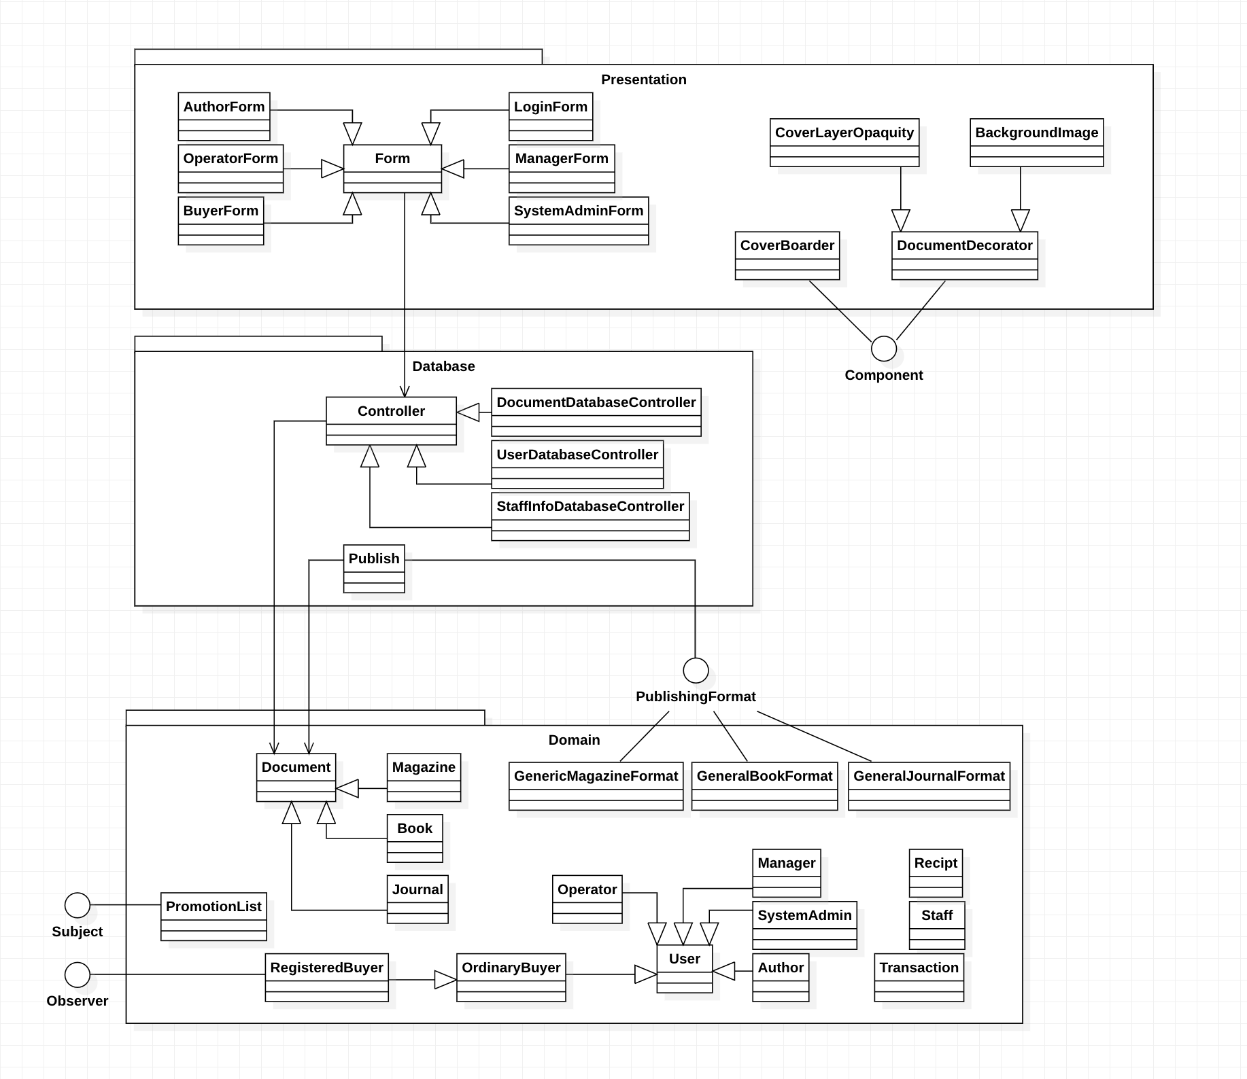

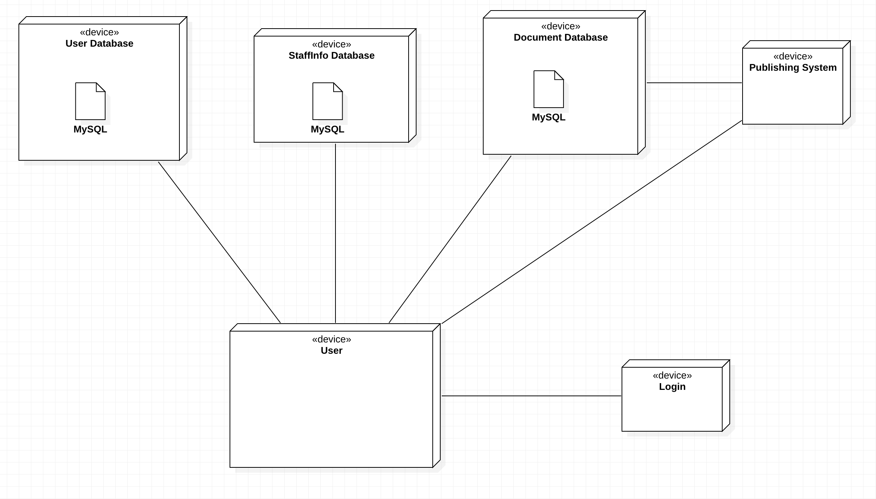**Deployment Diagram**